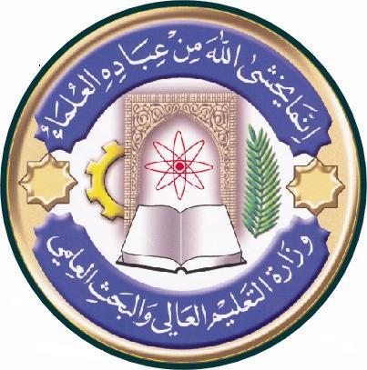
Republic of Iraq
The Ministry of Higher Education
& Scientific Research

University: Al-Qadissiyah
College: Biotechnology
Department: Medical Biotechnology
Stage: First Year Histology
Lecturer name: Dr. Miran ALRAMMAHI
Academic Status: Assist. Professor
Qualification: PhD
Place of work: Associate Dean for Administrative Affairs

Course Weekly Outline

Course Instructor | Dr. Miran Abed Alamer ALRAMMAHI
Email | Miran.AlRammahi@ qu.edu. iq
Title | Histology
Course Objective | - Basic principles - the concepts in this block guides the student through cell structure and basic tissues - the study of the basic building materials that make up every tissue and organ in the body.  - Musculoskeletal - this block guides students through identification and understanding of the structural and functional relationship between muscle and bone, the cellular basis for physiological function, and interpretation of the outcomes following pathological disorders of histological structure.  - Cardiovascular - this block guides students through identification and understanding of the structural and functional relationship between the various organs in the cardiovascular and lymphoid systems, the cellular basis for the composition of blood, and interpretation of the outcomes following pathological disorders of histological structure.  - Digestive & Pulmonary - this block guides students through identification and understanding of the structural and functional relationship between the various organs in the digestive and pulmonary systems, the cellular basis for physiological function, and interpretation of the outcomes following pathological disorders of histological structure.  - Renal - this block guides students through identification and understanding of the structural and functional relationship between the various components in the urinary systems, the cellular basis for physiological function, and interpretation of the outcomes following pathological disorders of histological structure.  - Endocrine & Reproductive - this block guides students through identification and understanding of the structural and functional relationship between the various organs in the endocrine and reproductive systems, the cellular basis for regulatory control, and interpretation of the outcomes following pathological disorders of histological structure.
Course Description | - The goal of the course is to enable students acquire the ability and skills necessary for recognizing normal tissue and organ structure and organization, correlate and integrate structure of tissues and organs with physiological and biochemical function, and apply the knowledge and understanding of tissue structure and function to disease processes, pathologies, manifestations, diagnosis, and treatment. The primary principle is that morphology of tissue provides very little meaning without a correlative understanding of the function associated with the tissue. The course is divided into six blocks: Basic principles, Musculoskeletal, Cardiovascular, Digestive & Pulmonary, Renal, Endocrine & Reproductive. The Basic Principles block guides the student through Cell Structure and Basic Tissues - the study of the basic building materials that make up every tissue and organ in the body. The remaining blocks cover Systems Histology – the study of microscopic anatomy of organ systems in the body. The material in the Basic Principles block is therefore a pre-requisite for a good understanding of the material in the Systems Histology blocks. Two dimensional imagery and microscopy is used throughout the course, but by the end of the course, students should have acquired a 3-dimensional understanding of tissue structure and organization. Students will be expected to learn histology by attending lectures, clinical-pathological correlations, small-group interactive table conferences (ITCH) and other interactive sessions (team-based learning, problem-based learning). Students will gain most from the course by reviewing material before and immediately following each learning session, and using practice quizzes to help measure their learning progress.
References | Lippincott’s Pocket Histology by Lisa M. J. Lee 2014  Ross and Wilson Anatomy and Physiology in health and illness 11th edition 2010
Course Assessment | Term Tests | Laboratory | Quizzes | Project | Final Exam
 | As (35%) | As (15%) | As (10%) | ---- | As (40%)

University: Al-Qadissiyah
College: Biotechnology
Department: Medical Biotechnology
Stage: First Year Histology
Lecturer name: Dr. Miran ALRAMMAHI
Academic Status: Assist. Professor
Qualification: PhD
Place of work: Associate Dean for Administrative Affairs

Republic of Iraq
The Ministry of Higher Education
& Scientific Research

Course weekly Outline
week | Date | Topics Covered | Lab. Experiment Assignments | Notes
1 |  | INTRODUCTORY HISTOLOGY
2 |  | EPITHELIA
3 |  | CONNECTIVE TISSUE
4 |  | BLOOD & HAEMOPOIESIS
5 |  | NERVE CELLS
6 |  | MUSCLE TISSUE
7 |  | BONE & CARTILAGE
8 |  | LYMPHOID TISSUE
9 |  | URINARY
10 |  | ENDOCRINE
11 |  | CARDIOVASCULAR SYSTEM
12 |  | RESPIRATORY SYSTEM
13 |  | MALE REPRODUCTIVE
14 |  | MAMMARY GLAND
15 |  | EYE & EAR
16

Instructor Signature: Dean Signature:
Dr. MIRAN ALRAMMAHI

