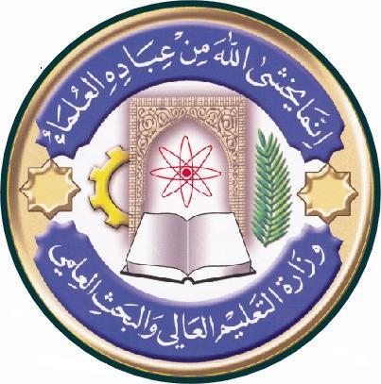
Republic of Iraq
The Ministry of Higher Education
& Scientific Research

University: Al-Qadissiyah
College: Biotechnology
Department: Medical Biotechnology
Stage: First Year Histology
Lecturer name: Hadeel jabar
Academic Status: Assist. Professor
Qualification: McS
Place of work: Associate Dean for Administrative Affairs

Course Weekly Outline

Course Instructor | Hadeel jabar neama
Email
Title | Histology
Course Objective | - Basic principles - the concepts in this block guides the student through cell structure and basic tissues - the study of the basic building materials that make up every tissue and organ in the body.  - Musculoskeletal - this block guides students through identification and understanding of the structural and functional relationship between muscle and bone, the cellular basis for physiological function  - of histological structure.
Course Description | - The goal of the course is to enable students acquire the ability and skills necessary for recognizing normal tissue and organ structure and organization, correlate and integrate structure of tissues and organs with physiological and biochemical function, and apply the knowledge and understanding of tissue structure and function to disease processes, pathologies, manifestations, diagnosis, and treatment.
References | Lippincott’s Pocket Histology by Lisa M. J. Lee 2014  Ross and Wilson Anatomy and Physiology in health and illness 11th edition 2010
Course Assessment | Term Tests | Laboratory | Quizzes | Project | Final Exam
 | As (35%) | As (15%) | As (10%) | ---- | As (40%)

University: Al-Qadissiyah
College: Biotechnology
Department: Medical Biotechnology
Stage: First Year Histology
Lecturer name: Dr. Miran ALRAMMAHI
Academic Status: Assist. Professor
Qualification: PhD
Place of work: Associate Dean for Administrative Affairs

Republic of Iraq
The Ministry of Higher Education
& Scientific Research

Course weekly Outline
week | Date | Topics Covered | Lab. Experiment Assignments | Notes
1 |  |  | EPITHELIA-1
2 |  |  | EPITHELIA-2
3 |  |  | CONNECTIVE TISSUE
4 |  |  | BLOOD & HAEMOPOIESIS
5 |  |  | NERVE CELLS
6 |  |  | MUSCLE TISSUE
7 |  |  | BONE & CARTILAGE
8 |  |  | LYMPHOID TISSUE
9 |  |  | URINARY
10 |  |  | ENDOCRINE
11 |  |  | CARDIOVASCULAR SYSTEM
12 |  |  | RESPIRATORY SYSTEM
13 |  |  | MALE REPRODUCTIVE
14 |  |  | MAMMARY GLAND
15 |  |  | EYE & EAR
16

Instructor Signature: Dean Signature:

