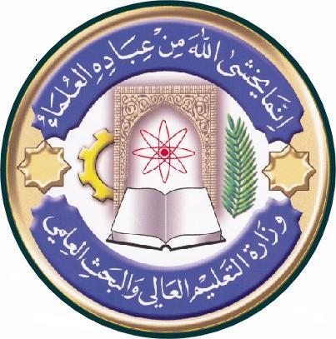
University: Al-qadesiayh
College: biotechnology
Department:medical Biotech.
Stage: Second
Lecturer name: Dr.Wafaa A-alkaby
Academic Status: lecturer
Qualification: PHD
Place of work: Alqadisiya University

Republic of Iraq
The Ministry of Higher Education
& Scientific Research

Course Weekly Outline

Course Instructor | Dr.Wafaa A-alkaby
E_mail | Wafaa 78-@yahoo.com
Title | Microbiology
Course Coordinator
Course Objective
Course Description | Description of the type and characterize of Bacteria, virus, fungi and parasite,
Textbook
References | Geof brook, jawets, batel (medcal of microbiology )  Simon P.hardy (human microbiology)
Course Assessment | Term Tests | Laboratory | Quizzes | Project | Final Exam
 | As (35%) | As (15%) | As (10%) | ---- | As (40%)
General Notes

University: Al-qadesiayh
College: biotechnology
Department:medical Biotech.
Stage: Second
Lecturer name: Dr.Wafaa A-alkaby
Academic Status: lecturer
Qualification: PHD
Place of work: Alqadisiya University

Republic of Iraq
The Ministry of Higher Education
& Scientific Research

Course weekly Outline
week | Date | Topics Covered | Lab. Experiment Assignments | Notes
1 |  | Introduction of microbiology
2 |  | Position of microbiology in microorganism
3 |  | Characterize of micro.
4 |  | Type of micro.
5 |  | Bacteria
6 |  | Fungi
7 |  | Parasite
8 |  | Virus
9 |  | Characterize of bacteria
10 |  | Internal and structure of bacteria
11 |  | Nutrient of bacteria
12 |  | Growth & Reproduction of bacteria
13 |  | Control of micro.
14 |  | Antibiotic
15
16
Half- year Break

Instructor Signature: Dean Signature:

