Republic of Iraq
The Ministry of Higher Education
& Scientific Research

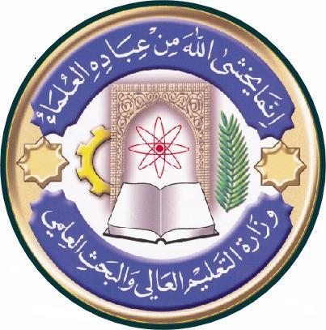
University: Alqadisiya University
College: College of Biotechnology
Department:Medecal Biotechnology
Stage:First stage
Lecturer name: Dr.Ghoson M.A.
Academic Status:Lecturere
Qualification:PHD
Place of work: Alqadisiya University

Course Weekly Outline

Course Instructor | Dr.Ghoson Mohammed Ali
E_mail
Title | Type here course title
Course Coordinator | Type here the came of course coordinator
Course Objective | Type here vourse objectives
Course Description | Type here course description
Textbook | Campbell Biology 10th ed. Pearson Benjamin Cummings, USA
References | Type here the reference (title,author,edition,publisher,year)
Course Assessment | Term Tests | Laboratory | Quizzes | Project | Final Exam
 | As (35%) | As (15%) | As (10%) | ---- | As (40%)
General Notes | Type here general notes regarding the course

University: Alqadisiya University
College: College of Biotechnology
Department:Medecal Biotechnology
Stage:First stage
Lecturer name: Dr.Ghoson M.A.
Academic Status:Lecturere
Qualification:PHD
Place of work: Alqadisiya University

Republic of Iraq
The Ministry of Higher Education
& Scientific Research

Course weekly Outline
week | Date | Topics Covered | Lab. Experiment Assignments | Notes
1 |  | INTRODUCTION & Orientation | Laboratory safety rules
2 |  | WATER AND LIFE | The Microscope
3 |  | CARBON AND THE MOLECULAR DIVERSITY OF LIFE | The cell
4 |  | CARBON AND THE MOLECULAR DIVERSITY OF LIFE | Macromolecules
5 |  | THE STRUCTURE AND FUNCTION OF LARGE BIOLOGICAL  MOLECULES | Biological membrane
6 |  | A TOUR OF THE CELL | Midterm Exam
7 |  | MEMBRANE STRUCTURE AND FUNCTION | Enzymes
8 |  | AN INTRODUCTION TO METABOLISM | Metabolism
9 |  | CELLULAR RESPIRATION AND FERMENTATION | Cell division
10 |  | PHOTOSYNTHESIS | Animal tissues
11 |  | THE CELL CYCLE | Plant tissues
12 |  | THE MOLECULAR BASIS OF INHERITANCE | Plant tissues
13 |  | FROM GENE TO PROTEIN | Plant tissues
14 |  | VIRUSES | Plant tissues
15 |  | Exam. | Exam.
16

Instructor Signature: Dean Signature:

University: Alqadisiya University
College: College of Biotechnology
Department:Medecal Biotechnology
Stage:First stage
Lecturer name: Dr.Ghoson M.A.
Academic Status:Lecturere
Qualification:PHD
Place of work: Alqadisiya University

Republic of Iraq
The Ministry of Higher Education
& Scientific Research

Course Weekly Outline

Course Instructor | Dr.Ghoson Mohammed Ali
E_mail
Title | General Biology I I
Course Coordinator | Type here the came of course coordinator
Course Objective | Type here vourse objectives
Course Description | Type here course description
Textbook | Campbell Biology 10th ed. Pearson Benjamin Cummings, USA
References | Type here the reference (title,author,edition,publisher,year)
Course Assessment | Term Tests | Laboratory | Quizzes | Project | Final Exam
 | As (35%) | As (15%) | As (10%) | ---- | As (40%)
General Notes | Type here general notes regarding the course

University: Alqadisiya University
College: College of Biotechnology
Department:Medecal Biotechnology
Stage:First stage
Lecturer name: Dr.Ghoson M.A.
Academic Status:Lecturere
Qualification:PHD
Place of work: Alqadisiya University

Republic of Iraq
The Ministry of Higher Education
& Scientific Research

Course weekly Outline

week | Date | Topics Covered | Lab. Experiment Assignments | Notes
1 |  | Resource acquisition and transport in vascular plants | Plant Diversity
2 |  | Water and minerals are transported from roots to shoots | Plant Diversity
3 |  | Stomata help regulate the rate of transpiration | Plant Anatomy
4 |  | Sugars are transported from leaves and other sources to sites of use or storage | Plant physiology
5 |  | The symplast is highly dynamic | The Prokaryotes
6 |  | Angiosperm reproduction & biotechnology | Midterm Exam
7 |  | Plant responses to internal and external signals | Enzymes
8 |  | Animal reproduction | Kingdom Protista
9 |  | Animal development | Kingdom Protista
10 |  | Circulation and gas exchange | Kingdom Fungi
11 |  | The immune system | The Invertebrates
12 |  | Osmoregulation and excretion | The Invertebrates
13 |  | Neurons, synapses and signalling | The Vertebrates
14 |  | Sensory and motor mechanisms | Animal tissue
15 |  | Exam. | Exam.

Instructor Signature: Dean Signature:

